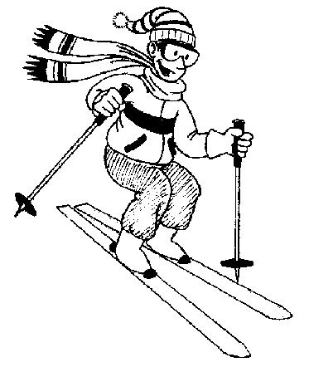
Date: Feb 23, 2008
Time: Sat, 6:30AM – 8:00PM
Place: Dodge Ridge(Sat)
Reg Fee: $75 (no rentals)
$110 (with rentals)

Forms DUE by Sunday, 17th.
First come first serve!
Only 30 spots available!

High School Ski TRIP
You WILL be sent home if you bring…

- cigarettes, alcohol, illegal drugs, etc.

You WILL be sent home if you…

- engage in any abusive, violent, or inappropriate behavior.

- In other words, if you wouldn’t do it in front of your parents, then don’t do it at the retreat!

Please bring…

- Ski / Snow board gear
- Snow Clothing and Accessories
- Sunblock
- An open mind and heart

Let’s play over snow!!!

Celebrate life, the future, hope, and the many blessings of the past.

Questions? Please contact Mr. Hahm (408) 203-2961 teens-pta@sbcglobal.net
Notes to Parents:

- Please return permission slips by Sunday, Feburary 17th! OR e-mail teens-pta@sbcglobal.net

- Drop students off at 6:30 AM on Saturday, Feb. 23 and pick up at 8:00 PM on Saturday, Feb 23.

- Please do not let students bring anything that may be a distraction (e.g. electronics such as PS2’s, etc. Cell phones are OK, as long as they are turned off.)

- If you need to contact your child during the trip, please call Mr. Hahm at 408)203-2961.
The Diocese of San Jose Parental Permission Form


531 East Weddell Dr. • Sunnyvale • CA • 94089 • Tel: (408) 734-9721 / 9722

Activity: High School Ski-trip
February 23, 2008

Location: Dodge Ridge Ski Resort

Cost: ( )$75 no rentals ( )$110 with rentals ( ) snowboard rentals ( ) ski rentals
Lift tickets are included in the price

Participant's Name: _________________________________ Student’s Phone: __________________

Email: ____________________________________________ (mandatory)

Address: _______________________________________________________________________________________

Grade: _____ Birthday: _____/_____/_____

Parent's Name: _________________________________ Parent’s Primary Phone:________________________

Parent’s Email: __________________________________________________________________

Person(s) other than Parent to notify in case of emergency:

Emergency Contact: _________________________________________ Phone: __________________ (mandatory)

Medical Insurer: _______________________________ Policy Number: _________________________ (mandatory)

I, the parent (guardian) of the above named child, hereby give my permission for his/her participation in the activity named above. I agree to direct my child to cooperate and conform to the directions and instructions of the leaders responsible for the activity.
I am not aware of any medical condition of my child that would make it inappropriate for him/her to participate. In case emergency medical attention is required, I hereby give permission for treatment that is deemed necessary and appropriate by the responding medical physician.
Execution of this document is not a waiver of any rights against any responsible party in the event of an accident caused by a third party, including an employee of the Diocese of San Jose.

Parent/Guardian Signature: _________________________________________ Date: ______________

Comments, requests: _______________________________________________________________________________

Office Use:

PAID: AMOUNT:$______ CASH: ___ or CHECK: ___ check #: ________

